**INDIA’S AGRICULTURAL CROP PRODUCTION ANALYSIS (1997-2021)**

**1**.**INTRODUCTION**

1.1 OVERVIEW

Crop production is a common agricultural practice followed by worldwide farmers to grow and produce crops to use as food and fibre. This practice includes all the feed sources that are required to maintain and produce crops.

India is the world’s second largest producer of many crops, including:

Wheat,Rice,Pulses,Jute,Groundnut,Vegetables,Fruit,Cotton,Sugarcane,Farmed fish, Sheep and goat meat, Tea.

India is also the world’s largest producer of milk, pulses and jute. It’s also a leading producer of spices, fish, poultry, livestock, and plantation crops. India has 195 million hectares (m ha) of land under cultivation. Of that, 63% is rain fed and 37% is irrigated. India’s agricultural crop year is from July to June. The cropping season is divided into two main seasons: Kharif and Rabi. India’s production of food grains has been increasing every year. However, crop yields are still generally lower compared to the world average.

1.2 PURPOSE

Agriculture is an important sector of the Indian economy. It provides food, fodder, and raw materials for the country. It also plays a role in international business through import and export activities. Agriculture contributes about 17% to India’s total GDP and provides employment to over 60% of the population. It’s the largest source of livelihoods in India. 70% of rural households depend primarily on agriculture for their livelihood. 82% of farmers are small and marginal.

Agriculture **impacts** society in many ways, including: Supporting livelihoods through food, habitat, and jobs. Providing raw materials for food and other products. Building strong economics through trade.

Agriculture’s economic contribution to India’s GDP is steadily declining with the country’s broad-based economic growth. However, it still plays a significant role in the overall socio-economic fabric of India. The **purpose** of crop production is to grow crops that can be sold or used for food, feed, fuel and fibre. The **goal** of crop production is to produce a high yield of quality crops.

**2. Problem Definition & Design Thinking**

2.1 EMPATHY MAP

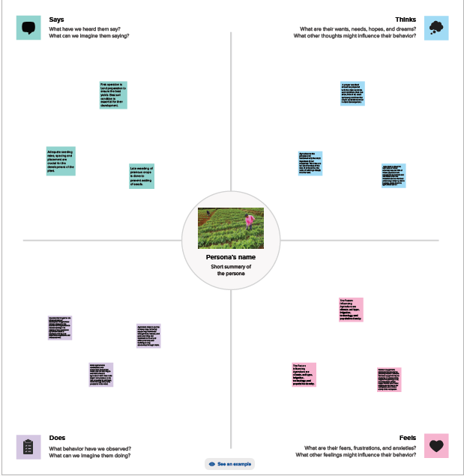

2.2 IDEATION AND BRAINSTORMING MAP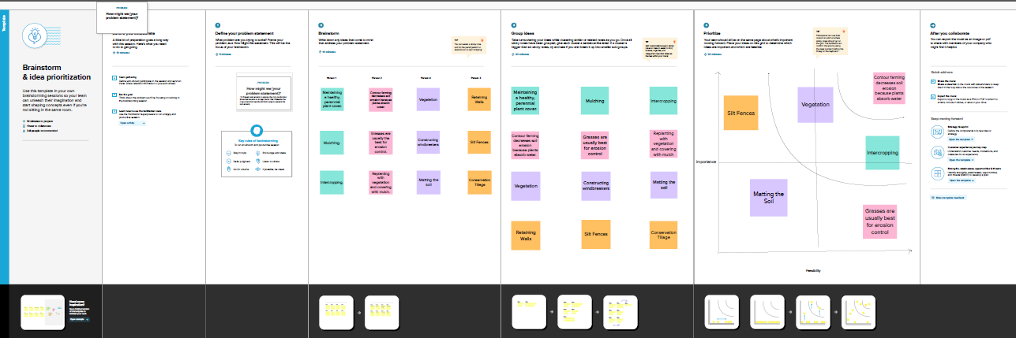

**3. RESULTS**

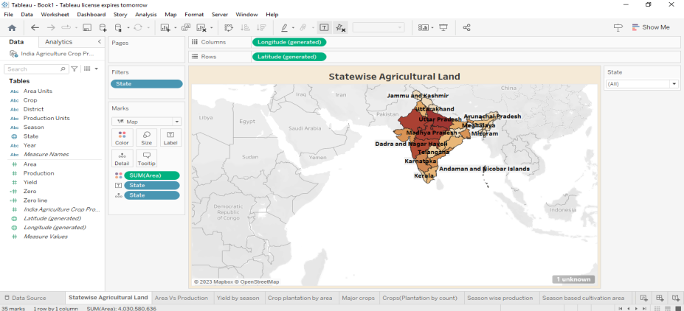

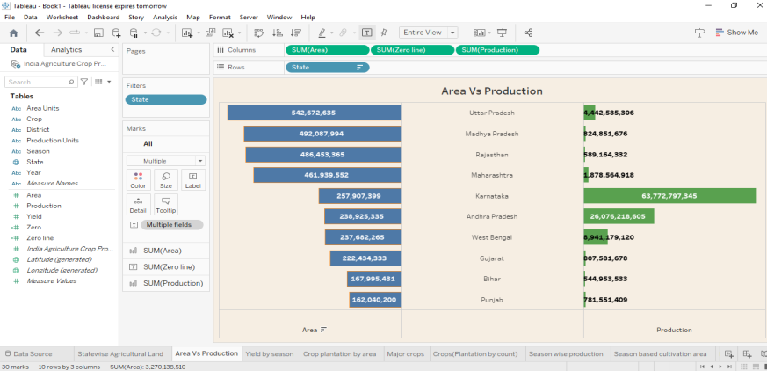

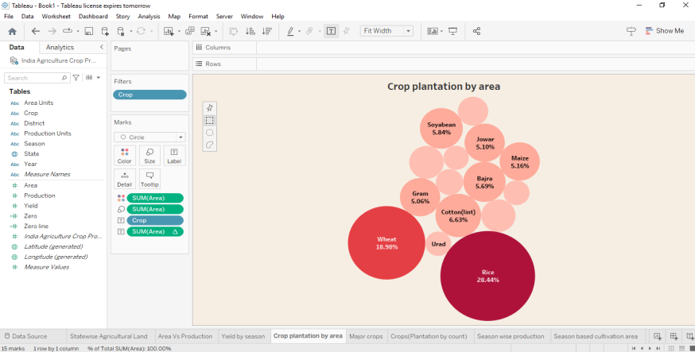

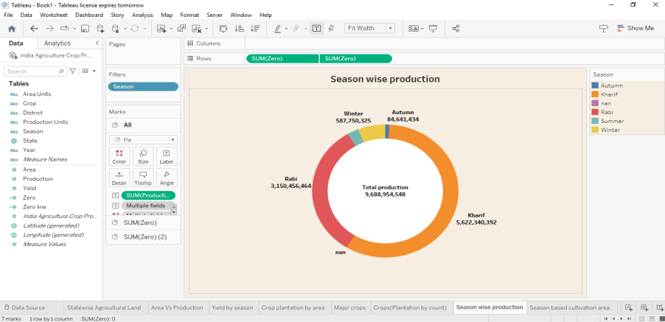

**4. ADVANTAGES & DISADVANTAGES**

ADVANTAGES:

1. Limiting Pollution.

2. Protecting soil from erosion, salinity, and acidity.

3. Crops are food for living creatures and raw materials for most products.

4. Reducing pests and disease and improving the quality of fruits and flowers.

5. Crop production enhances crop productivity, soil nutrient levels and economic benefits to farmers.

6. Sustainable agriculture practices improve soil fertility through crop rotation, use of animal manure instead of synthetic fertilizers and cover cropping.

7. The use of fertilizers has helped farmers to get better yield of crops such as wheat, paddy and maize.

DISADVANTAGES:

1. Climate change: Rising temperatures and changing weather patterns can lead to lower crop yields.

2. Water scarcity: Drought, heat waves, and flooding can cause water scarcity.

3. Soil degradation: Intensive farming can cause soil degradation and lead to the expansion of new lands.

4. Pest and weed resistance to chemicals: Pests and weeds can become resistant to chemicals.

5. Crop failure: There is no insurance against crop failure.

6. Soil infertility: An unchanging pattern of cultivation can deplete certain minerals in the soil infertile.

**5. APPLICATIONS**

Crop production is a common agricultural practice that involves growing and producing crops for food and fibre. Crops are used for many purposes, including:

FOOD: Agronomic crops provide food, feed grain, oil, and fiber for domestic consumption.

FIBER: Fibre-rich crops like bamboo can be turned into a pulp, which can then be used to make paper.

BIOFUEL: Agriculture is the cultivation of animals, plants, fungi, and other life forms for food, fibre, bio fuel and other products used to sustain life.

Crop production can be improved by using nanotechnology to address agricultural problems like excessive use of fertilizers and pesticides and plant stress induced by extreme climate. And using ISFM practices to diversify nutrient sources, maximize input use efficiency and maintain balanced nutrient stock.

Crop improvement is essential to meet the demands of changing world (eg , increased population, climate change, and decreasing land base). Plant breeding programs are continuously striving to increase crop yield, enhance crop quality, and improve crop tolerance to diseases and pests.

**6. CONCLUSION**

The agricultural sector is undergoing a process of transition to a market economy. Agricultural production is increasingly susceptible to rainfall variability, even in irrigated environments. Comprehensive knowledge of rainfall patterns, frequency of dry and wet spells occurrence, and the estimated assured rainfall is important for proper crop planning. Modern farming methods are revolutionizing the agricultural industry by providing farmers with data-driven insights and sustainable farming options.

**7. FUTURE SCOPE**

The future scope of crop production is to meet the increasing demand for food. Food demand is expected to double by 2050 due to a growing population and shifts in consumption patterns from starchy foods to protein-rich foods. To meet this demand, crop production will need to increase by 25%-70% above current levels. Technology can also help unlock value in agriculture. The use of more and smoother connections between soil farm equipment and farm managers could unlock $130 billion to $175 billion in value by 2030.